Appendix B
Illustrated Pattern Mini-Atlas
Early Seronegative Peripheral Inflammatory Arthritis
This mini-atlas provides schematic illustrations for the five imaging patterns described in Section 6 of the main manuscript. Each pattern page includes anatomical localization, key morphological features, phenotype direction, principal mimics, and recommended next-test escalation.
How to use this atlas: When interpreting imaging in early seronegative peripheral inflammatory arthritis, match observed findings to the pattern templates below. Use the topography, morphology, and associated features to estimate phenotype probability, then follow the 'Best Next Test' guidance for question-driven escalation.
Note: These schematic illustrations are educational aids, not diagnostic images. Pattern matching should be integrated with clinical context, distribution analysis, and activity markers as described in the main text.

Pattern A: Marginal Microerosion Candidates at Classic RA Sites
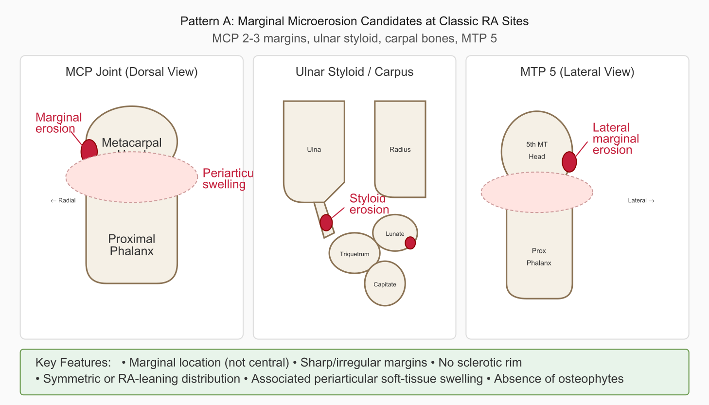
Figure B1. Marginal microerosion candidates at classic RA-prone sites
Topography | MCP 2–3 (radial margins), ulnar styloid, carpal bones (lunate, triquetrum), MTP 5 (lateral margin), PIP margins
Morphology | Small (<2 mm) marginal cortical defects; sharp or irregular margins; no sclerotic rim (differentiates from degenerative); may be visible on one projection only
Associated Features | Periarticular soft-tissue swelling; symmetric or near-symmetric distribution; absence of osteophytes; tenosynovitis/synovitis on US-PD
Phenotype Direction | RA-like (seropositive pattern without serology)
Key Mimics | Bare areas (smooth, symmetric); sesamoid articulations (MCP, MTP); vascular channels; projection artifacts
Best Next Test | US-PD of symptomatic joints and tendon compartments to confirm activity; MRI if BME assessment would change risk posture

Pattern B: Enthesitis-Adjacent Cortical Changes
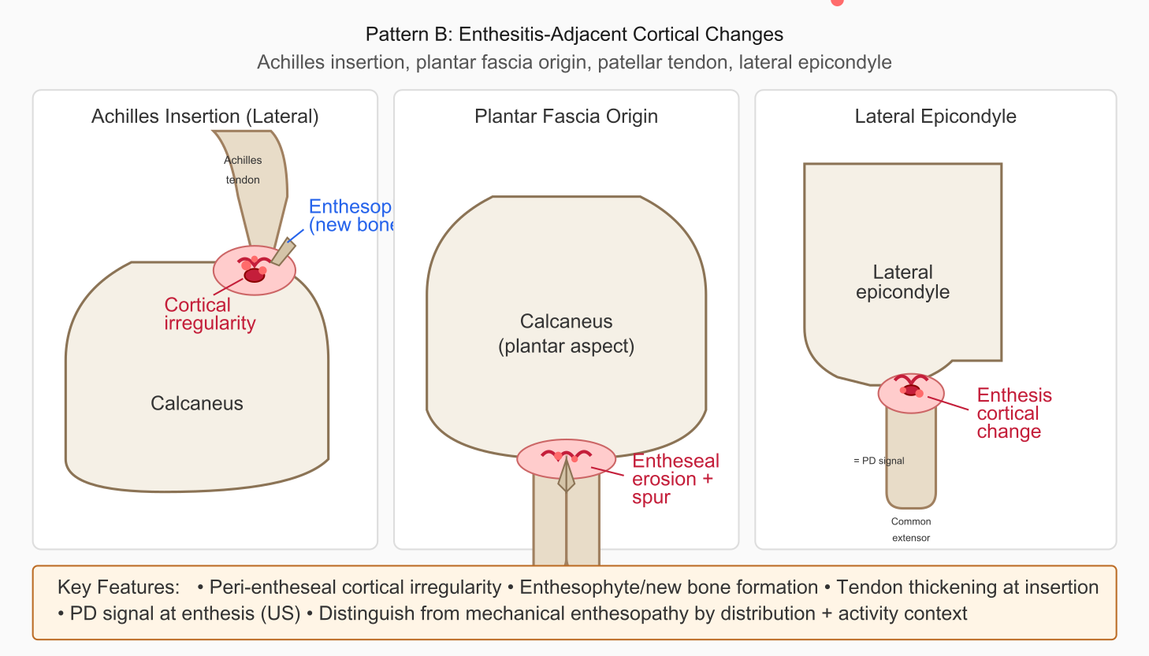
Figure B2. Enthesitis-adjacent cortical changes at common peripheral sites
Topography | Achilles insertion (calcaneus), plantar fascia origin, patellar tendon insertion (tibial tuberosity), lateral epicondyle, greater trochanter
Morphology | Cortical irregularity or erosive change at tendon/ligament insertion; adjacent enthesophyte formation; periosteal reaction at insertion zone
Associated Features | Soft-tissue thickening at insertion; PD signal at enthesis (US); tendon thickening; dactylitis if digits involved
Phenotype Direction | PsA/SpA-like (spondyloarthritis spectrum)
Key Mimics | Mechanical enthesopathy (overuse, degenerative); isolated degenerative enthesophytes without activity
Best Next Test | US-PD of entheses and adjacent tendon sheaths; MRI for calcaneal BME if Achilles involvement suspected

Pattern C: Periosteal Reaction and Fluffy New Bone
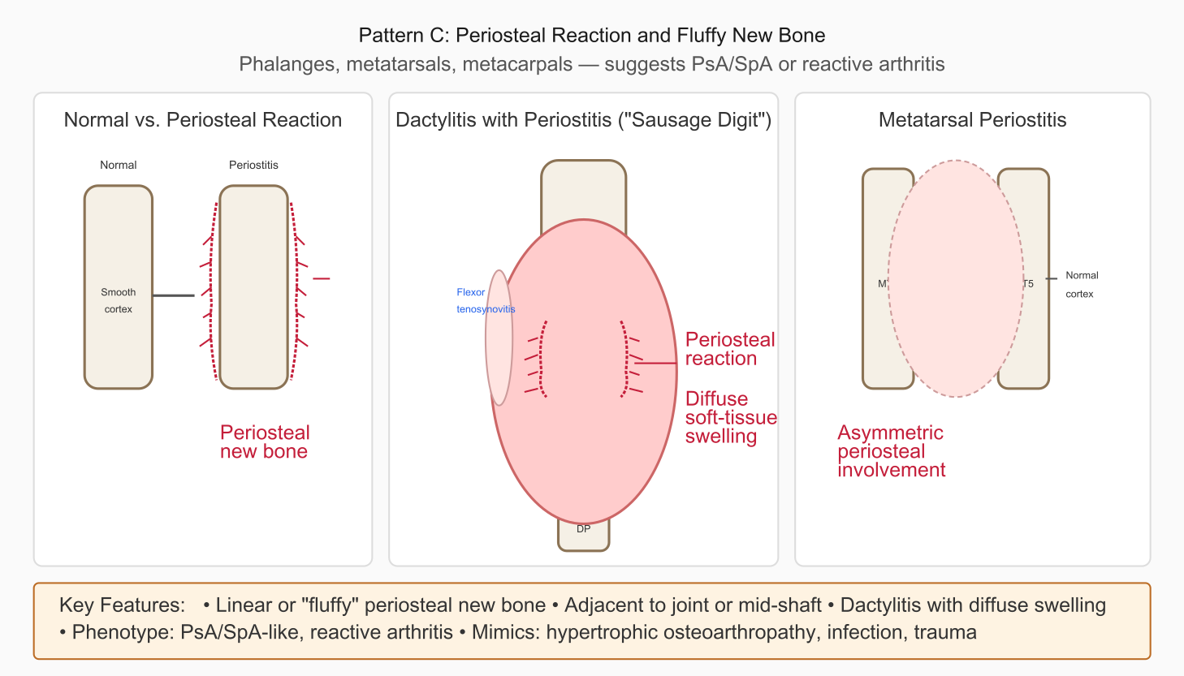
Figure B3. Periosteal reaction and fluffy new bone formation with dactylitis
Topography | Phalanges (proximal, middle), metatarsals, metacarpals; periarticular diaphyses; may be adjacent to joint or mid-shaft
Morphology | Linear periosteal new bone formation; "fluffy" or irregular periostitis; whisker-like spicules perpendicular to cortex
Associated Features | Dactylitis ("sausage digit"); diffuse soft-tissue swelling along entire digit; flexor tenosynovitis; entheseal involvement at same level
Phenotype Direction | PsA/SpA-like; reactive arthritis; consider SAPHO if sternoclavicular involvement
Key Mimics | Hypertrophic osteoarthropathy; infection (osteomyelitis); trauma; malignancy (single site, aggressive periosteal pattern)
Best Next Test | US-PD for soft-tissue/tenosynovitis assessment; MRI if infection or malignancy concern (aggressive pattern, systemic features)

Pattern D: DIP Involvement with Nail Changes
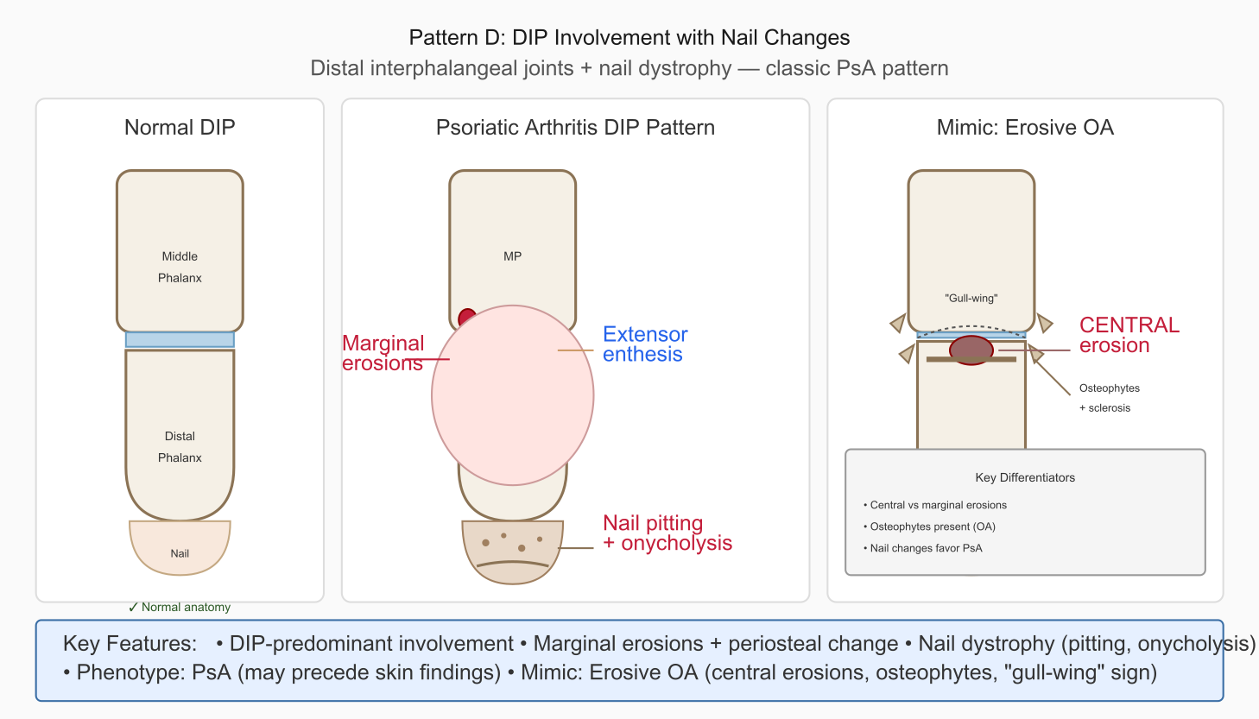
Figure B4. DIP involvement with nail changes (PsA) versus erosive OA comparison
Topography | Distal interphalangeal joints (hands and feet); adjacent nail bed and matrix
Morphology | Marginal erosions at DIP; periosteal change; "pencil-in-cup" deformity (advanced); erosions at extensor tendon insertion
Associated Features | Nail dystrophy: pitting, onycholysis, hyperkeratosis, oil-drop discoloration; entheseal change at extensor insertion
Phenotype Direction | PsA (classic presentation); may precede skin manifestations by years
Key Mimics | Erosive OA (central erosions, "gull-wing" sign, osteophytes, subchondral sclerosis); gout (rare at DIP, but possible)
Best Next Test | Dermatology referral for occult psoriasis (scalp, umbilicus, gluteal cleft); US-PD of DIP and nail bed; consider MRI for complex cases

Pattern E: Asymmetric Oligoarticular Distribution
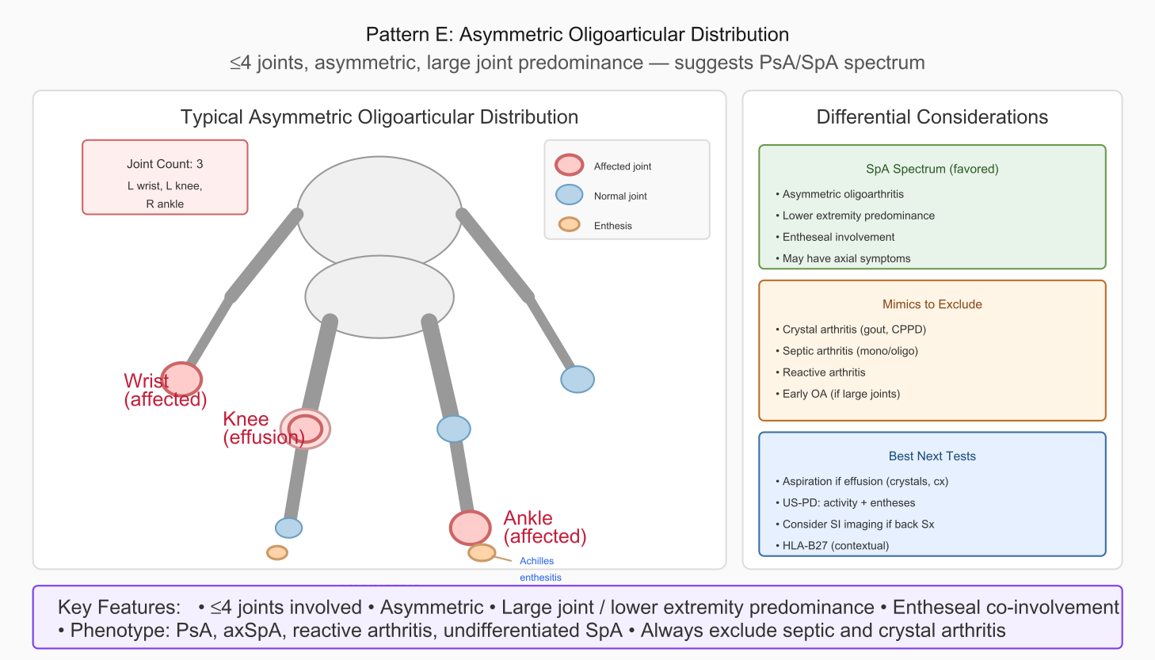
Figure B5. Asymmetric oligoarticular distribution with differential considerations
Topography | Large joints (knee, ankle, wrist); ≤4 joints involved; asymmetric; lower extremity predominance common
Morphology | Joint effusion; periarticular erosion (if advanced); entheseal involvement at same joint or region
Associated Features | Lower extremity predominance; heel pain (Achilles/plantar enthesitis); sacroiliac symptoms; dactylitis in digits if present
Phenotype Direction | SpA-spectrum (axSpA, PsA, reactive arthritis); undifferentiated SpA
Key Mimics | Crystal arthritis (gout, CPPD); septic arthritis; trauma; early large-joint OA
Best Next Test | Aspiration if effusion present (crystals, culture); US-PD for activity + entheses; consider SI joint imaging if back symptoms; HLA-B27 (contextual)

Quick Reference Summary
Pattern | Key Location | Phenotype | Best Next Test
A: Marginal microerosions | MCP 2-3, ulnar styloid, MTP 5 | RA-like | US-PD joints/tendons
B: Enthesitis-adjacent | Achilles, plantar fascia, epicondyle | PsA/SpA-like | US-PD entheses
C: Periosteal/fluffy bone | Phalanges, metatarsals | PsA/SpA, reactive | US-PD; MRI if concern
D: DIP + nail changes | DIP joints, nail bed | PsA (classic) | Derm referral; US-PD
E: Asymmetric oligo | Large joints, ≤4, asymmetric | SpA-spectrum | Aspirate; US-PD; SI imaging?
Table B1. Quick Reference: Five Patterns for Early Seronegative Peripheral IA

